Project Planning Phase

Project Planning Template (Product Backlog, Sprint Planning, Stories, Story Points)
Project Title | DarshanEase: A Smart Temple Darshan Booking System Using MERN Stack
Team ID | ALITS-CSD-2026-DarshanEase
Team Members | Salapala Tharun Kumar Reddy (Team Leader); A. Goutham; M. Siva Prasad; M. Akhila; K. Hemalatha
College | Anantha Lakshmi Institute of Technology and Sciences (ALITS)
Academic Year | 2026

Product Backlog, Sprint Schedule, and Estimation
Sprint | Functional Requirement (Epic) | User Story Number | User Story / Task | Story Points | Priority | Team Members
Sprint-1 | Registration & Login | USN-1 | As a user, I can register with email, phone, and password. | 2 | High | M. Akhila
Sprint-1 |  | USN-2 | As a user, I receive confirmation once registered. | 1 | High | M. Akhila
Sprint-1 |  | USN-3 | As a user, I can log in with email and password. | 2 | High | K. Hemalatha
Sprint-1 | Temple Listing | USN-4 | As a user, I can browse the list of temples. | 2 | Medium | A. Goutham
Sprint-2 | Temple Details | USN-5 | As a user, I can view detailed temple information. | 2 | Medium | A. Goutham
Sprint-2 | Darshan Booking | USN-6 | As a user, I can select a date and slot to book darshan. | 3 | High | S. Tharun Kumar Reddy
Sprint-2 | Booking Confirmation | USN-7 | As a user, I receive a confirmation with booking ID. | 2 | High | S. Tharun Kumar Reddy
Sprint-3 | Booking History | USN-8 | As a user, I can view past and upcoming bookings. | 2 | Medium | M. Siva Prasad
Sprint-3 | Journey Planner | USN-9 | As a user, I can search bus/train/flight options. | 3 | Medium | M. Siva Prasad
Sprint-3 | Notifications | USN-10 | As a user, I receive a booking confirmation notification. | 1 | Low | K. Hemalatha
Sprint-4 | Admin Dashboard | USN-11 | As an admin, I can manage temples and slots. | 3 | High | S. Tharun Kumar Reddy
Sprint-4 | Admin Dashboard | USN-12 | As an admin, I can view and manage all bookings. | 3 | High | A. Goutham

Sprint velocity summary
Sprint | Total Story Points | Duration
Sprint-1 | 7 | 1 week
Sprint-2 | 7 | 1 week
Sprint-3 | 6 | 1 week
Sprint-4 | 6 | 1 week
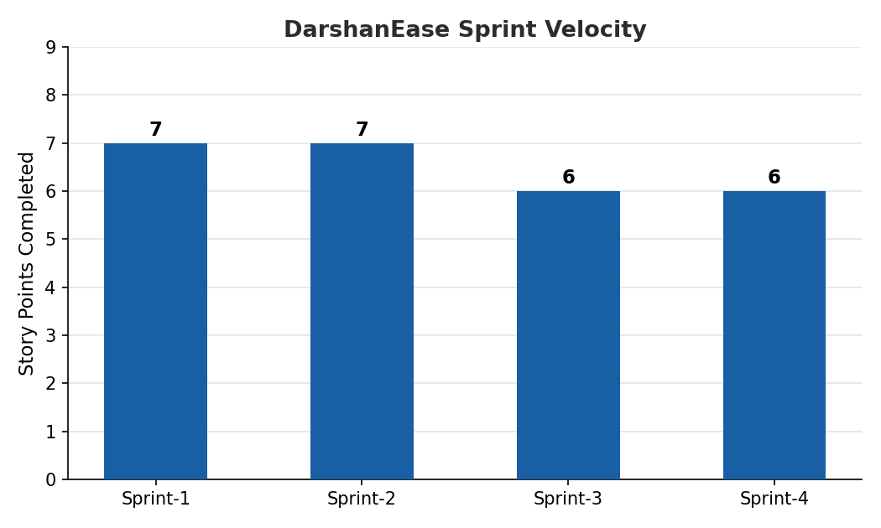
Figure: Sprint velocity across the DarshanEase backlog

